**Assignment 6**

**Simulate RPC (Create procedure on remote machine and call it from local machine)**

**List of programs for RPC**

**1. String is palindrome or not.**

**2. Find out given year is Lear Year or not.**

**3. Find out the GCD of given number.**

**4. Find out the square root of given number.**

**5. Swap two variables without using 3rd variable.**

**6. Calculate Maximum, Minimum, average of given array.**

**7. Compare the given two strings.**

**8. Find out whether given string is substring or not.**

**9. Concatenate the two strings.**

**10. Reverse the elements of an array.**

**Server:**

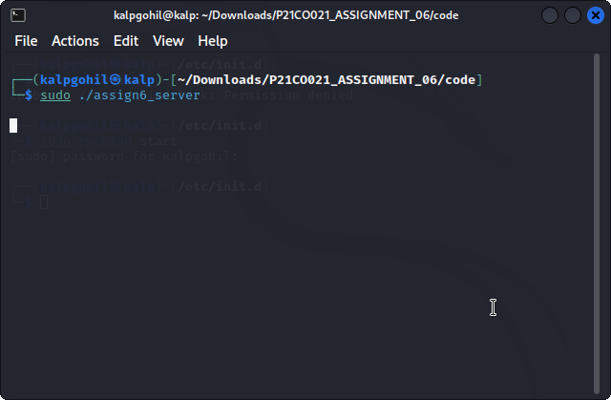

**Client:**

